ASSIGNMENT 2: AWS INFRASTRUCTURE WITH ARGO CD

- Keep AWS resources and CI flow as in ASSIGNMENT 1
- Install argo CD

RUN COMMAND

- Create namespace:
kubectl create namespace argocd
- Apply argocd
kubectl apply -n argocd -f https://raw.githubusercontent.com/argoproj/argo-cd/stable/manifests/install.yaml
- Use Load Balancer to view argo UI
kubectl patch svc argocd-server -n argocd -p '{"spec": {"type": "LoadBalancer"}}'
Go to url “a3a5ae5c786374ed5acedaf1c5b61702-520099965.ap-southeast-1.elb.amazonaws.com”
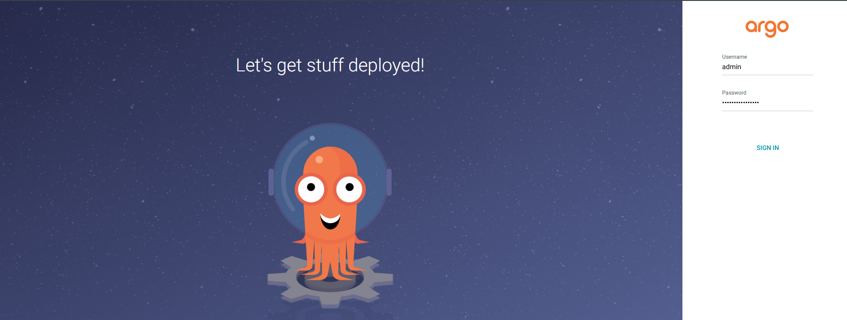

- Run command to get password
kubectl get secret -n argocd argocd-initial-admin-secret -o jsonpath="{.data.password}" | base64 -d

- Type username=”admin” and password=”8rjs6YrUw6qz9S2U” -> Sign in
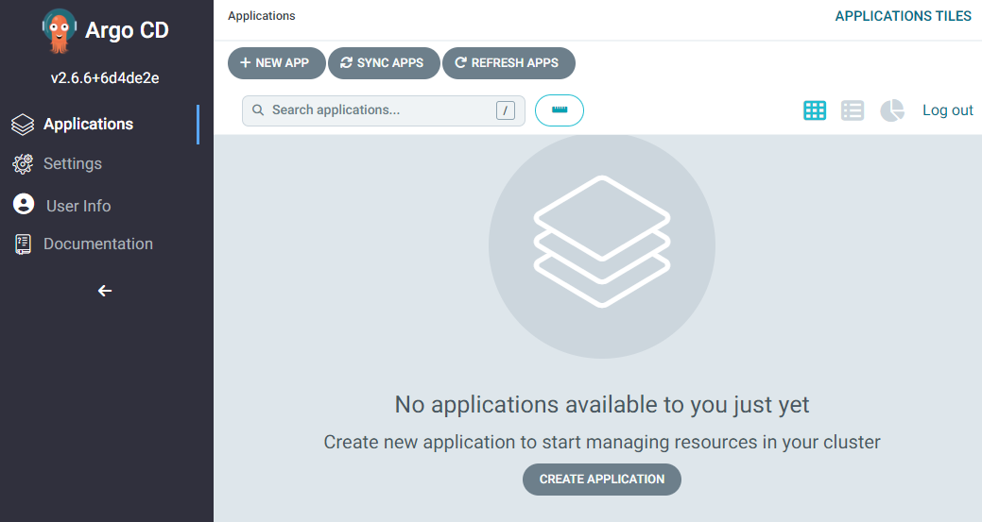

- Create argo application

- Create a file “applicationargo.yaml”
repoURL: https://github.com/ngocdung12112000/SD5804_MSA/blob/main/applicationargo.yaml

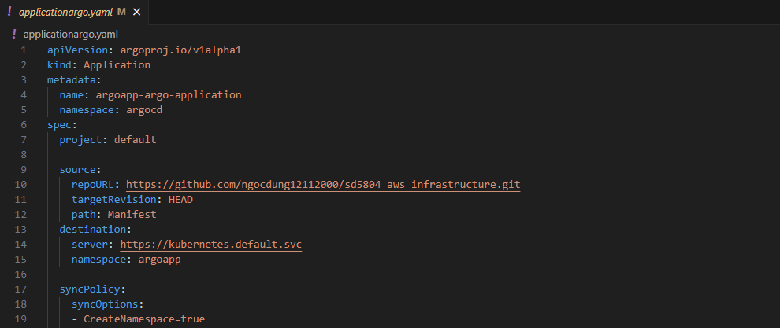

- Run command to create argo application
kubectl apply -f applicationargo.yaml

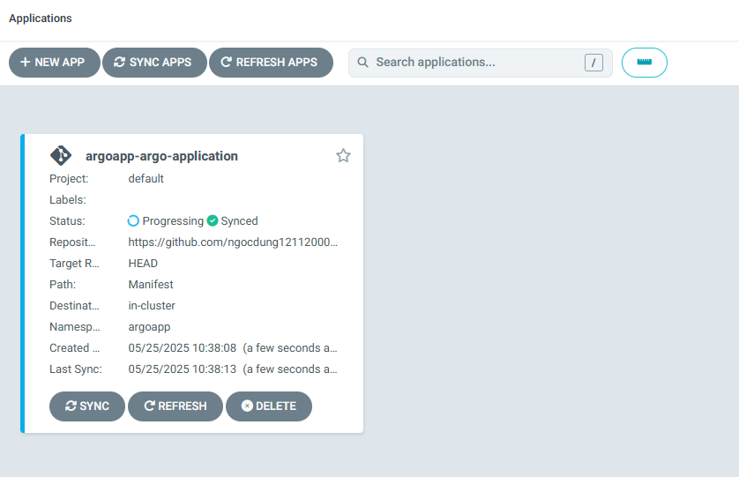

- Click to argo app-argo-application and click Sync

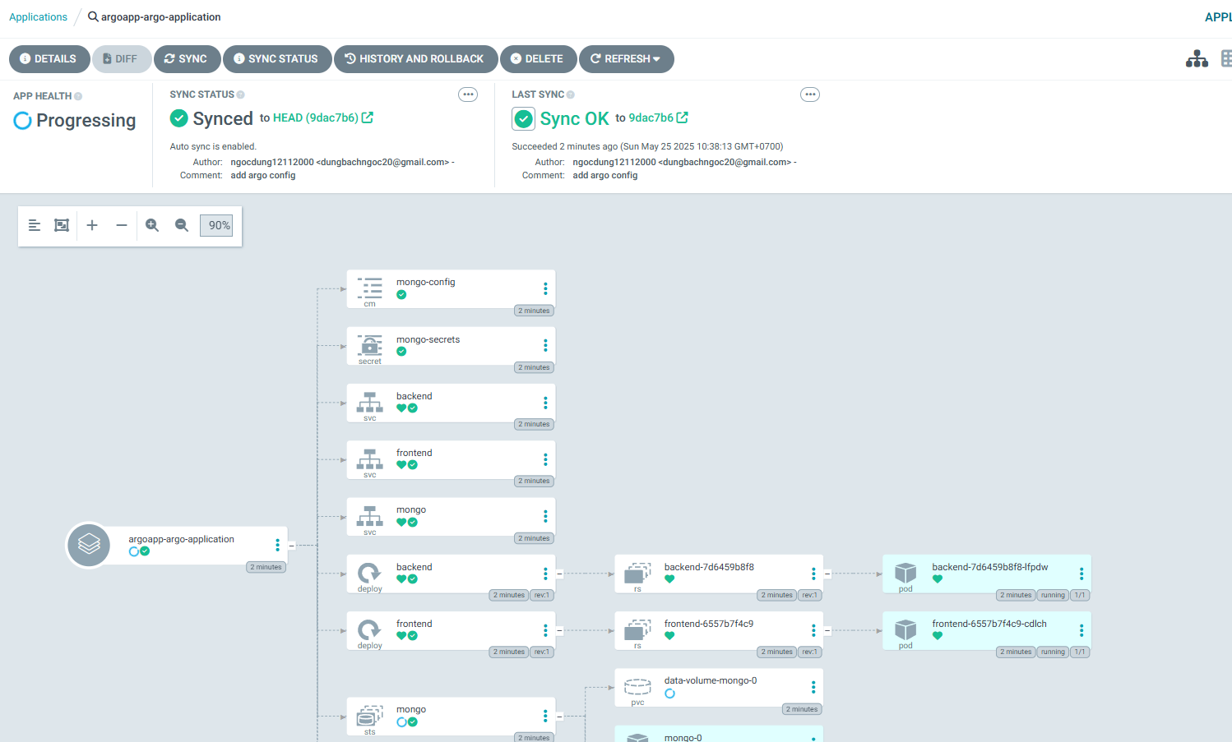

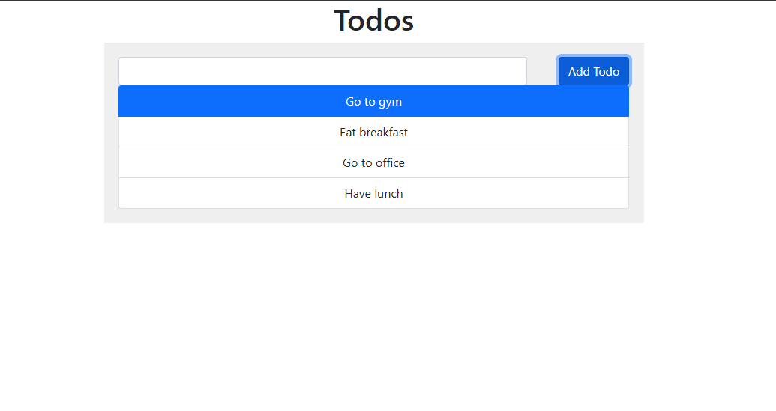

- Update image frontend

Change from frontend:v1 -> frontend:v2
Then commit change and push

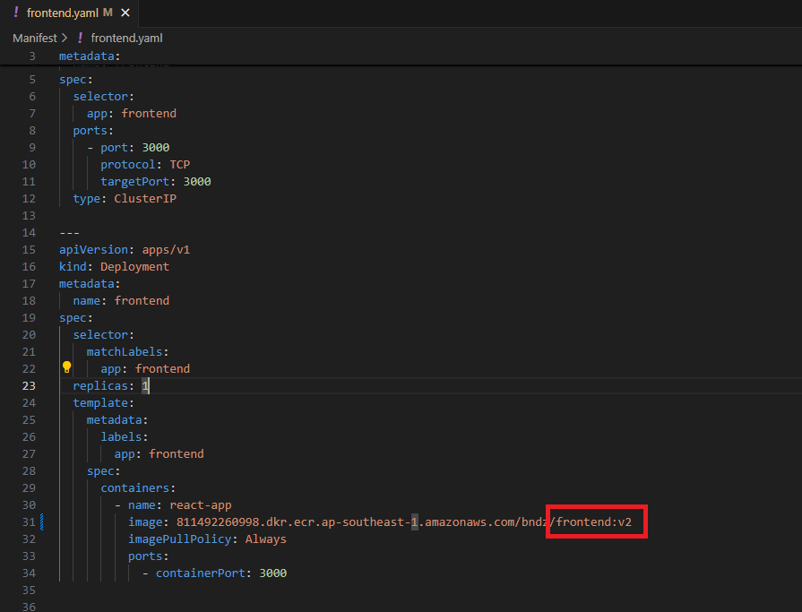

In argo UI, it show Sync status: Out of sync
-> Click Sync button -> Synchronize
Check frontend pods
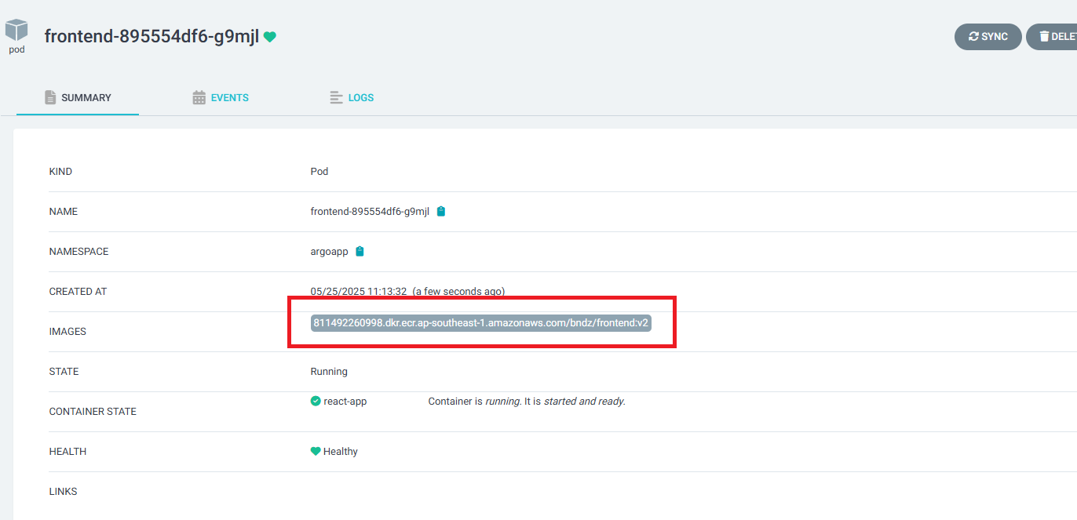
Check UI

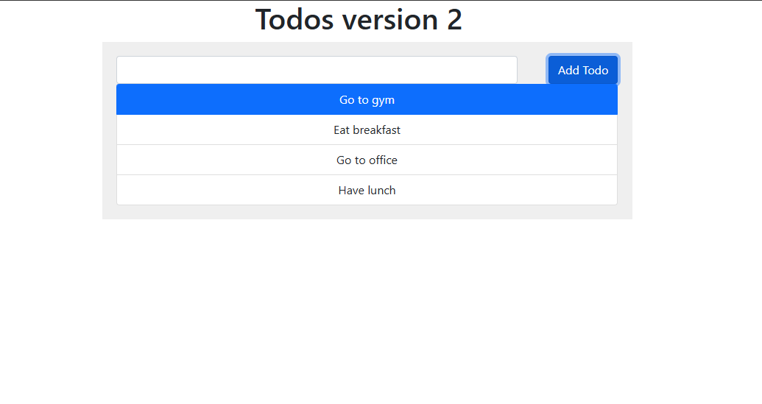

- Update backend replicas

Change replicas: 1 -> replicas: 3
Commit change and push

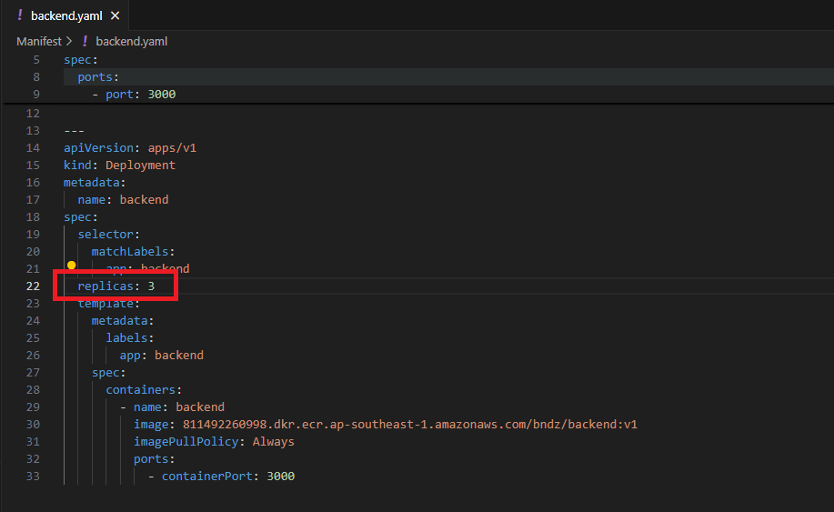

In argo UI, Click Diff button

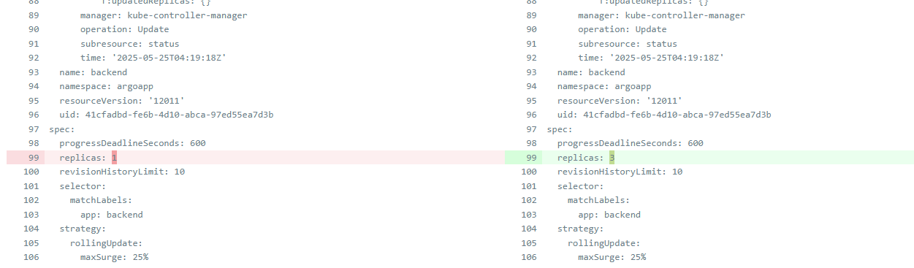

Then click Sync button -> Synchronize
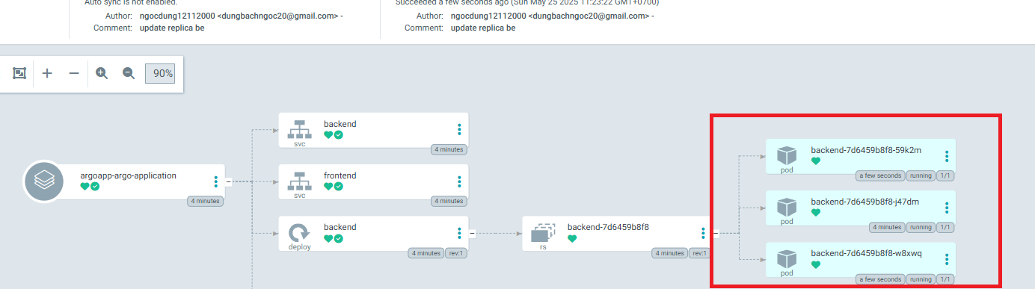

Now there are 3 pods for backend

